KIET Website Required Content

PROGRAMS TAB :
Visit : Kiet-Website-Programs-Tab

- Course image : Undergraduate, Graduate and Diploma (Size- 1920px*500px).
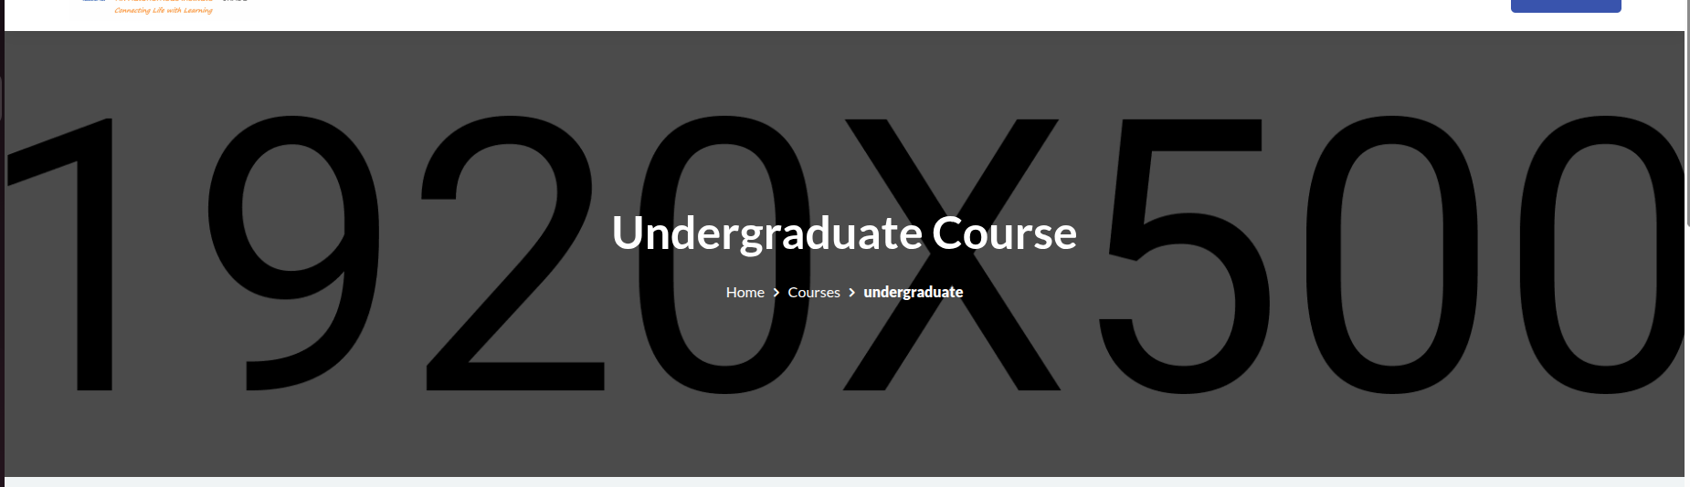

- Each Department Image of size 310px*220px and total Intake of each department .

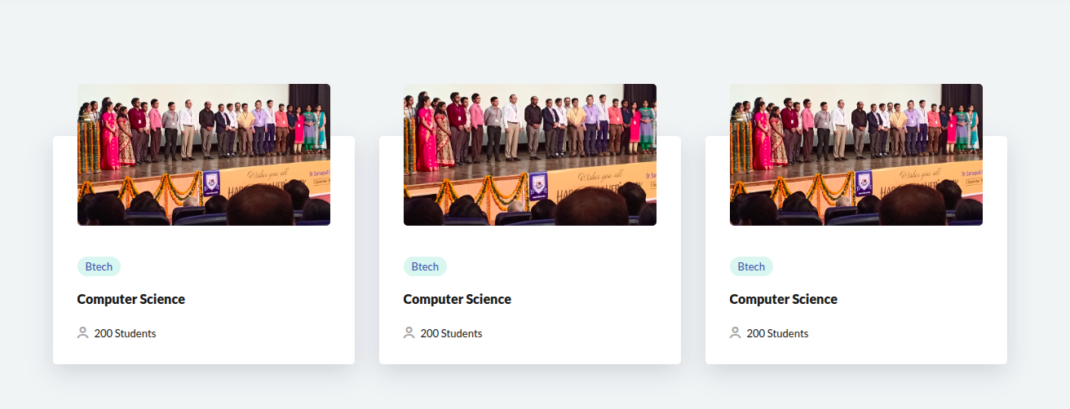

DEPARTMENT PAGE

- Departments Image (1920px * 500px)
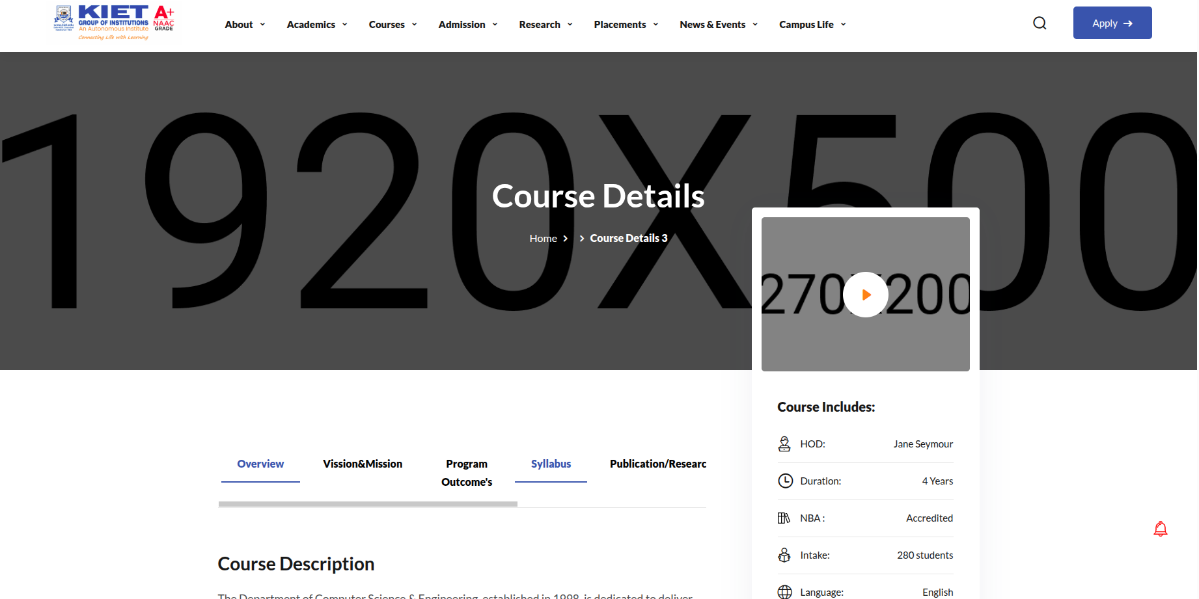

- Intro YouTube video link of each department .
- HOD Name, NBA accreditation, Duration, total intake.
- Overview of the department
- Vision and Mission of department (points)
- Program Outcomes
- Syllabus (PDF/Image)
- Publication/Research
- Faculty and Staff :
  - Name
  - Image (370px * 370px)
  - Designation

- Testimonials:
  - Name
  - Image (370px * 370px)
  - Message
  - Designation
  - Department + Batch (Year)
- Centres of Excellences

